**CRM – Admin Dashboard Details**

**General Notes:** We want to have a mobile responsive CRM. We don’t want to have a horizontal scroll bar on any part/area of CRM. We want our CRM in both Light and Dark Modes. We want to have clean, and smooth CRM with nice and Minimal Animations. We want to show breadcrumps also.

Following are the links for the designing of both light mode and dark mode. You need to copy the design. We will share all the details below.

**Dark Mode Sample 1:** <https://crm-admin-dashboard-template.multipurposethemes.com/project_management/vertical/main-mini-dark/index.html>

**Dark Mode Sample 2:** <https://crm-admin-dashboard-template.multipurposethemes.com/sales/vertical/main-mini-dark/index.html>

**Light Mode Sample 1:** <https://crm-admin-dashboard-template.multipurposethemes.com/project_management/vertical/main/index.html>

**Light Mode Sample 2:** <https://crm-admin-dashboard-template.multipurposethemes.com/sales/vertical/main/index.html>

Above these links are only for the design purpose, content/tabs will be different. We will list a detail of what tabs We need and what will be in these tabs.

**List of Main Tabs:**

1. Dashboard
2. Leads
3. Projects
4. Sales
5. Clients
6. Chats
7. Partners
8. Staff
9. Support

**Top Bar**

Now, let’s discuss about Top bar which will be always visible, it doesn’t matter which tab you open. The bar should look like this



Let’s start from left side.

1. First we will have our logo.
2. Next, we need toggle option to open and close sidebar (you can check out sample links).
3. Next, in this top bar you can see a Search option, we ***don’t*** need Search option. You can skip.
4. Next, there’s an option of Notifications, we need this in our CRM. All notifications from all the tabs must be visible there. For example, if someone opened a ticket in support then that notification must be appear there. If a client send message, it should also show a notification also that say “A New Message from Roberto” something like that, it’s just an example. I hope you got the point.
5. Next, we have an option for Quick Links. We also want to show that option. We want to show some options there. (i) Projects (ii) Customers (iii) Clients (iv) Partners (v) Staff (vi) Settings
6. On next option, we would like to show Notifications, and Ticket Details there e:g, ticket opened at 11:45, ticket answered as 11:56 etc etc. We don’t want to show audit logs or settings there as you can see in the sample links.
7. We want to show Chat option there, so we can easily access Chats from there.
8. Next we have Cart option, and a Language option, we ***don’t*** want to show them here. You can skip these options.
9. We need to add a ***button/icon*** to switch from Dark to Light or Light to Dark Mode*. (Most Important)*. We need to show that icon before Full Screen icon.
10. Next option is Full Screen option and we would like to Add that option.

This is for the top bar. Design will be same like sample links. How they will appear everything, you need to copy from sample design.

1. **Dashboard**

Now, let’s discuss about our primary area, Dashboard. Below screenshot is the example of how and what we want to show on our dashboard. First of all, we will have ***6 boxes*** (as you can see screenshot for idea) those will show us the data which you can see in screenshot.

*(Screenshot Attached Below)* In front of those 6 boxes we will have ***“Recent Activity”*** section which is most important. It is basically same thing as the notifications which we discussed above in “Top Bar Area” *(Ref Point no 4 in top bar area).* Each single action performed on the CRM will be visible on “Recent Activity” area. Actions like, Bill Paid by Mike, John Created New Lead, Project CX780 delivered, 452 Milestone Completed etc. All kinds of actions performed in any tab will be shown in “Recent Activity” area.

*(Screenshot Attached Below)* Next we have ***“Upcoming Deliveries”*** in the dashboard as you can see in the screenshot. In the below screenshot, you can see 4 Rows in Upcoming Deliveries area. But over here, we need 5 Rows in it (we don’t want any horizontal scroll bar in it). The rows will be:

* Order No
* Days Left
* Project Name
* Deadline
* Client Name

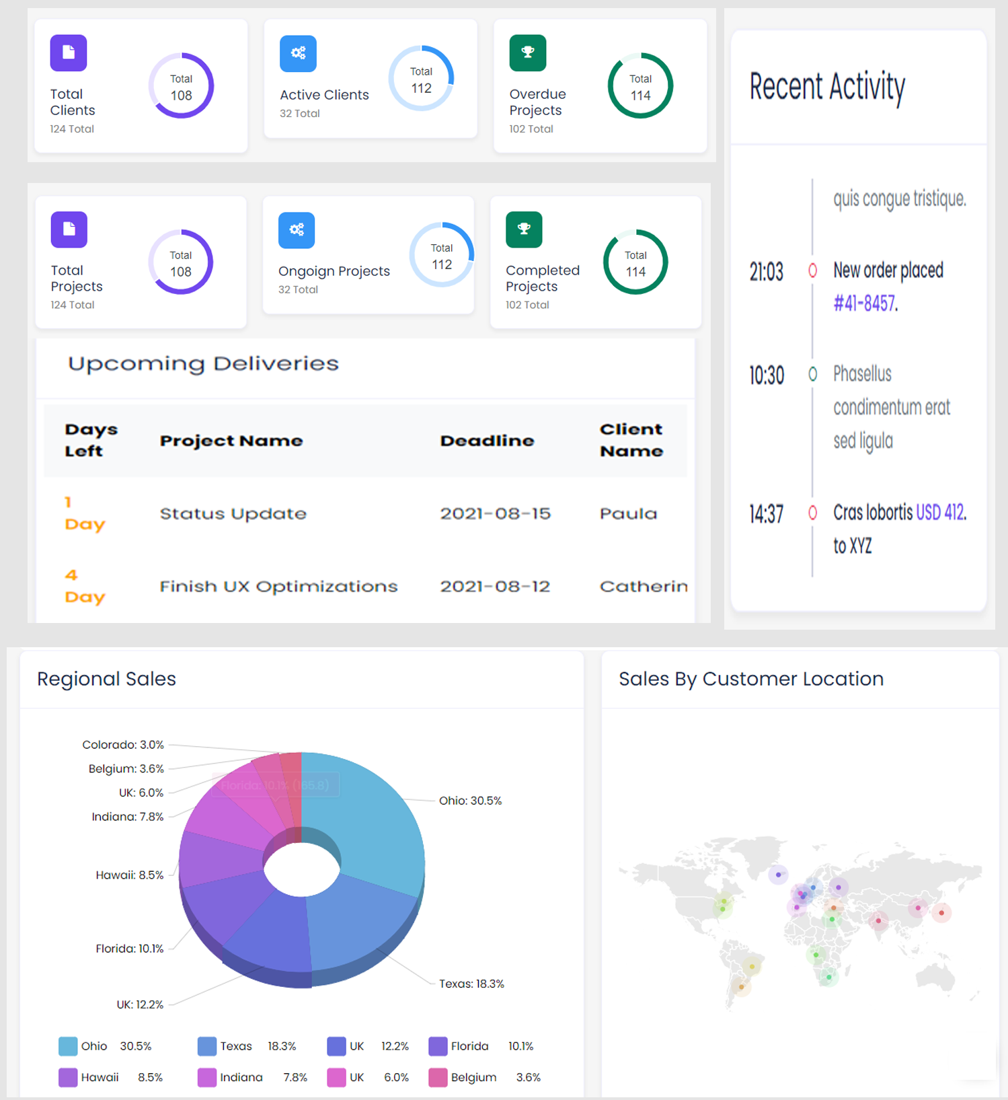

In this screenshot, you can see ***“Regional Sales”*** and ***“Sales by Customer Location”.*** How this will work? When a client will join us, he/she will must provide his/her address. These both sections will be linked with that address. If a client put the State “Ohio” then it will be shown here with graph, and if client puts the state “Texas” in his address, then graph will also show Texas too. This is how this graph will work and show the data to us. Please see screenshot and sample links, it will be easy for you to understand it.

1. **Leads**

Now, we have Leads section now. This is the sections which you need to develop in Partners Dashboard with minor changes. Below sketch (screenshot) will explain you how we want to have a look of our Leads section.

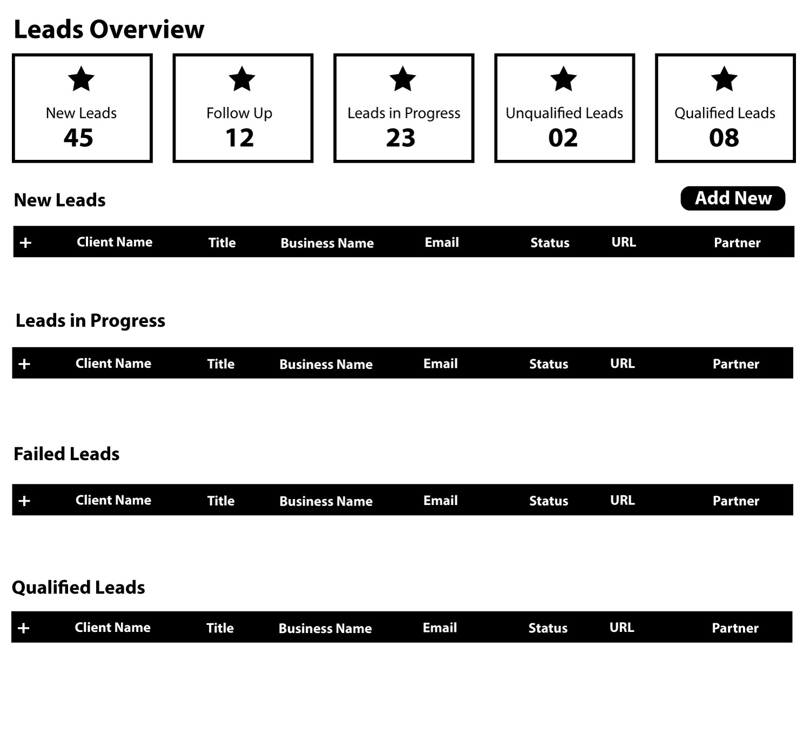

Now let’s start from Leads Overview, we will have 5 boxes which will show us overall data and progress. Star in each box indicates the icon, you need to Add related icons there. Next we have “Add New” button from where we will add new leads into it. When someone will click on “Add New” a pop-up form should appear with following. (i) Client Name (ii) Title (iii) Business Name (iv) Email Address (v) Status (vi) URL (vii) Partner (viii) State, Country (ix) Address (x) Phone Number (xi) Date (xii) Follow-up Date.

These 12 options must be asked in a pop-up from when someone will click on “Add New”. The first 7 options (from Client Name to Partner) will be listed in the table and will be visible. Rest of 5 will be hidden under plus sign. When someone will click on **+** then rest of information will be visible. We also need to have “Edit” and “Save” button to update the information in the future.

As you can see in screenshot, all of them are separate tables. “New Leads”, “Leads in Progress”, “Failed Leads”, & “Qualified Leads” all of these are separate tables. In these tables and its option the most important & functional Row/Option will be “***Status”***. There will be 6 types of status. We want same colors for these Status buttons. These buttons will be appear in dropdown.



Let’s explain this further, when a new customer will contact us we will Add New Lead by Putting all of his necessary/required information that will be Added in a “New Leads” table. Than we will contact them, and we will change the status from “New Lead” to ”Contacted”. If client replied then ok, otherwise we will follow up after a few days. When we will follow-up, we will change the status from ”Contacted” to ”Follow-up”. Till now, the lead will be in 1st table (New Leads).

When client will reply and start discussion about project we will change the status from ”Follow-Up” to ”Lead-in-Progress”. The Lead will shift/move from 1st table (New Leads) to 2nd table (Leads-in-Progress). *(Once the lead shift from 1st table to 2nd, it shouldn’t be visible in 1st table. Same applies for rest of tables.)*

After the discussion with client, if we failed to convince him for services we will mark the Lead as “Failed”. The status will be changed from ”Lead-in-Progress” to ”Failed”. At that point, lead will shift/move from “Lead-in-Progress” (2nd table) to “Failed Leads” (3rd table). And if he becomes our client we will mark the Lead as “Qualified”. The status will be changed from “Lead-in-Progress” to “Qualified”. At that point, lead will shift/move from “Lead-in-Progress” (2nd table) to “Qualified Leads” (4th table).

Now the next point is table’s preview. See attached screenshot.

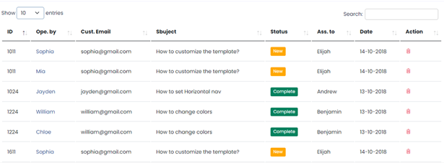

This screenshot is just to give you an idea of how these tables will look like. Just ignore this table’s information.

*Design idea-purpose only.*

*We want to have search bar and filter options on above each table. The status buttons should look prominent with the colors we attached above. If the word “Lead-in-Progress” doesn’t comes right in the place of button because of spacing issue, you can only write “In-Progress”.*

1. **Projects**

Now we have our most detailed and important part “Projects”. See attached screenshot/sketch for Projects Section outlook.

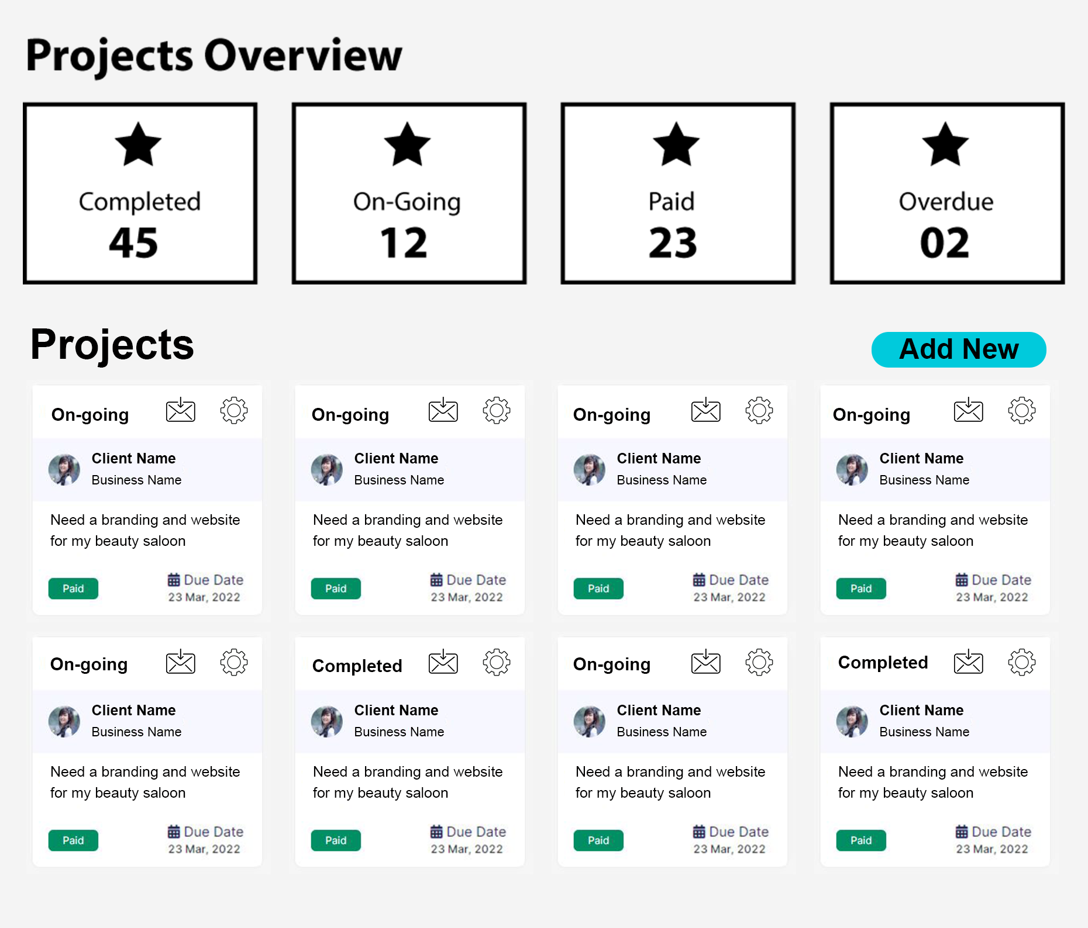

Now let’s start from Projects Overview, we will have 4 boxes which will show us overall data of projects. Star in each box indicates the icon, you need to Add related icons there.

First 2 boxes are about Total Number of Projects Completed and On-Going Projects. Next 2 boxes are about billing, how many Paid and how many Overdue. The above screenshot shows the look of our project section overview.

Let’s discuss about details. First of all, we will have a Status of project (Completed/Or-Going). Next we will have inbox notifications point. When a client will message us, the Inbox icon will have a Red notification icon which will tell us that this client sent a message. *When we will have a large number of projects, it will be a confusion for us to understand and reach out to a specific client to answer their queries so this will help us to reach out quickly.* Next we will have settings (will appear in pop-up) from where we will be changing Status (Completed/On-Going), Image, Client Name, Business Name, Project Name, and Billing Status (Paid, Overdue).

Next we will have to show image, Client Name, and Business Name (you can see in the screenshot). Under that, we will have a Project Name (2 lines for project name). After project name, we will have a Billing Button (Paid/Overdue) *paid will be in Green Button, and Overdue will be in Red Button.* Next in right bottom corner, we will have a Due Date of Project to show.

In the above screenshot as you can see we have **a “Add New”** button. We want that button to Add New projects. When someone will click on “Add New” the pop-up will appear with form. There will be the following fields in the form to Create/Add New Project. (i) Client Name (ii) Business Name (iii) Project

That’s it. We only want 3 fields initially to Create/Add New Project. Next details will be explained below with screenshots.

As we mentioned in the start, this is the most detailed part of our CRM. After the creation/addition of new project, we will be able to see project in “Projects” area where other projects will be. When we will click on Client Name/Business Name/Image that means we want to open the details of that project. When we will click on it we will see following preview. *See attached Screenshot/Sample/Sketch.*

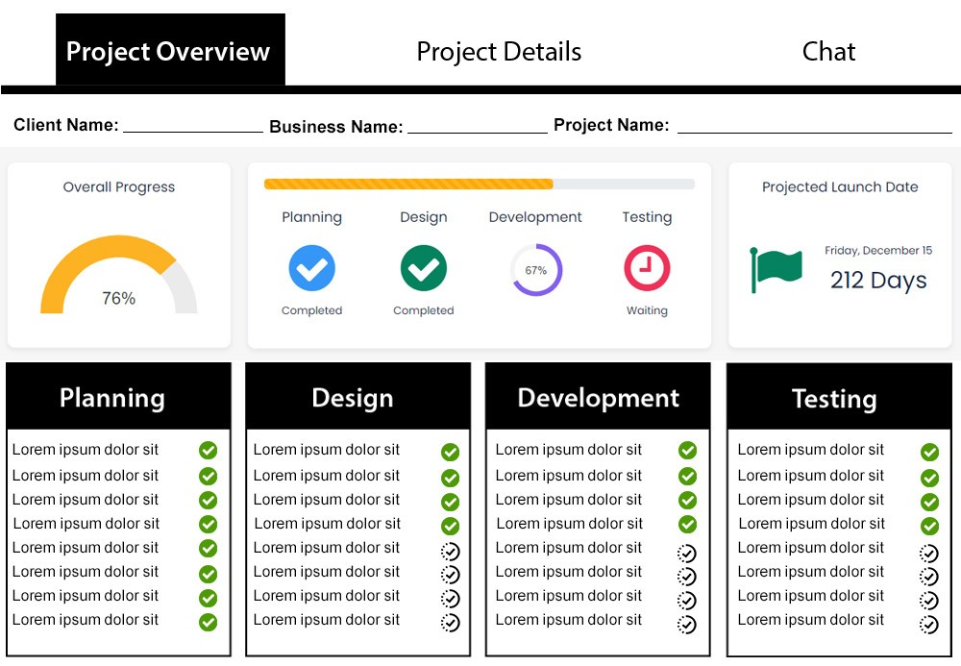

You can see 3 tabs here. (i) Project Overview (ii) Project Details (iii) Chat

***Now, let’s start from first tab***. The first tab “Project Overview” tab will be **“Read Only”** tab, that means we will not be able to edit that tab’s information from here. We want to show the Client Name, Business Name, and Project Name on top and after that we will have rest of information. This tab will only show us the progress of a specific project. Overall Progress, Project Timeline, and Projected Launch Date will be shown as it is.

Next we have 4 boxes, Planning, Design, Development, & Testing. The text in these boxes is a dummy. For now, assume that we have tasks listed here. When our team will complete the task, they will mark the task as completed *(Green Check Mark in screenshot shows us that this task has been completed)*. The other check mark with dotted line show us that “we’re working on that project”. This is for the first tab (Project Overview) of Projects.

Now, ***let’s see how the tab 2*** (Project Details) will look like. *See attached Screenshot/Sample/Sketch.*

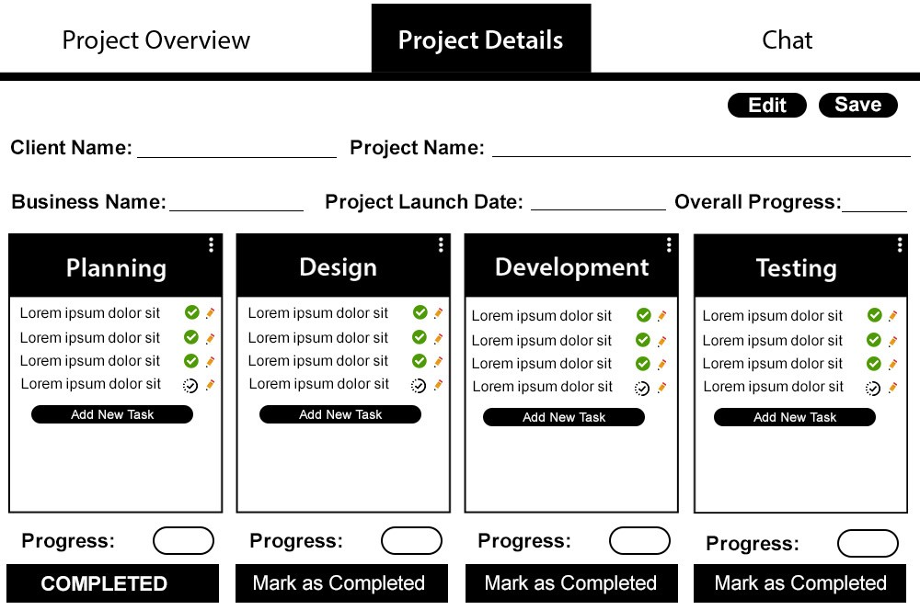

This the screenshot/sample view/sketch of Tab 2 (Project Details). ***This whole tab will be editable. All the changes related to project will be made from here.*** *What changes we will make here, all of them will be applied and visible and Tab 1.*

On top right corner, you can see Edit and Save button (for editing and saving all updates). Next we will put Client Name, Project Name, Business Name, Project Launch Date (you need to show the calendar when we click to set a project due date.), and Overall Progress *(this will also be editable, we will itself update the progress. Max number is 100, make sure to put limit of 100 on this)*.

Next, you can see 4 boxes here these will be here by default. You can see 3 dots in Top right corner of each box. The purpose of these boxes is to edit the name of the box. When we will change the box name, the name will be automatically changed from *Box in Tab 1* and from *Project Timeline in Tab 1*. Next from here, we will Add New Tasks, which will be visible on Tab 1. Add New Task will have a small pop-up with Field to write a task on it and then save. In front of task name, we will have Green Check Mark (Sign of Completion) and Edit button to edit the task name anytime. There must be an option to change the status of task *(Green Check Mark will be the Sign of Completion, and Black Check Mark with dotted circle will show that this task is in Progress).* When we will mark the tasks completed on Tab 2, then it will be automatically updated on Tab 1. *There is no limit to Add more tasks in each box.*

Under the box, we will have an option of Progress of that specific box *(the progress of that box will be visible on Tab 1 in the Project timeline)*. *(Progress Score box will also be editable, we will itself update the progress. Max number is 25 for each box and total of 4 will be 100, make sure to put limit of 25 on each box)*. Lastly, we will have a prominent button to mark the Box as completed. When we will click on **“Mark as Completed”,** the button color will also be changed and the button text will be **“COMPLETED”.** *It must be updated on Tab 1 in Project Timeline area.*

Now, ***let’s see how the tab 3*** (Chats) will look like. *See attached Screenshot/Sample/Sketch.*

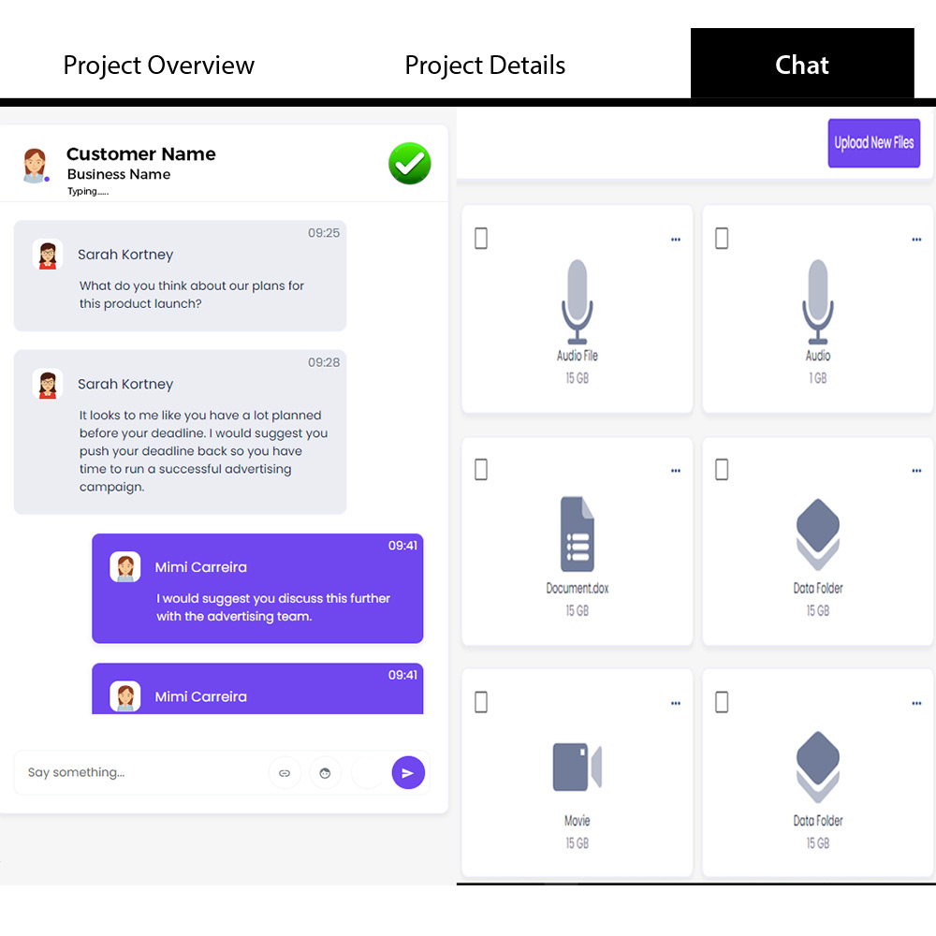

This will be the preview of Chat area. We want to show chat area Exactly like this. The only difference you need to make is to keep Chat area wider then files area.

1. **Sales**

In sales area, we will have 2 boxes on the top, Total Number of Sales and Total Sales (Revenue). Additionally, you want to add filter which will show data according to time. When we click on 3 dots, the following options should appear. Last Week, Last Month, Last 3 Months, Last 6 Months, Last 12 Months, Overall.

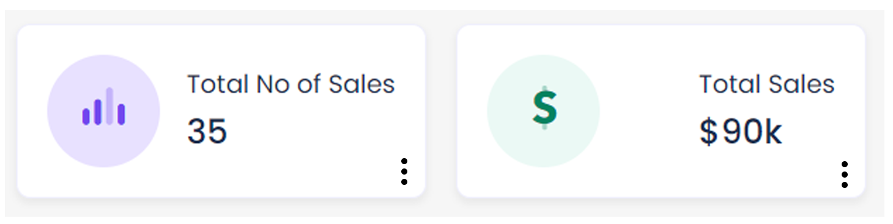

We also want to show 2 more sections in sales (you’ve already developed in Main Dashboard). The name of those sections are (i) Recent Activities (ii) Upcoming Deliveries

***We want to integrate Invoices in Sales section.***

We need to create Invoice Generator in order to create invoices for our clients.

<https://crms-reactjs.dreamguystech.com/template/invoices> this is the invoice system we would like to Add in our CRM. We need to integrate this complete invoice system in our CRM including all the options which you can see in this link related to invoice.

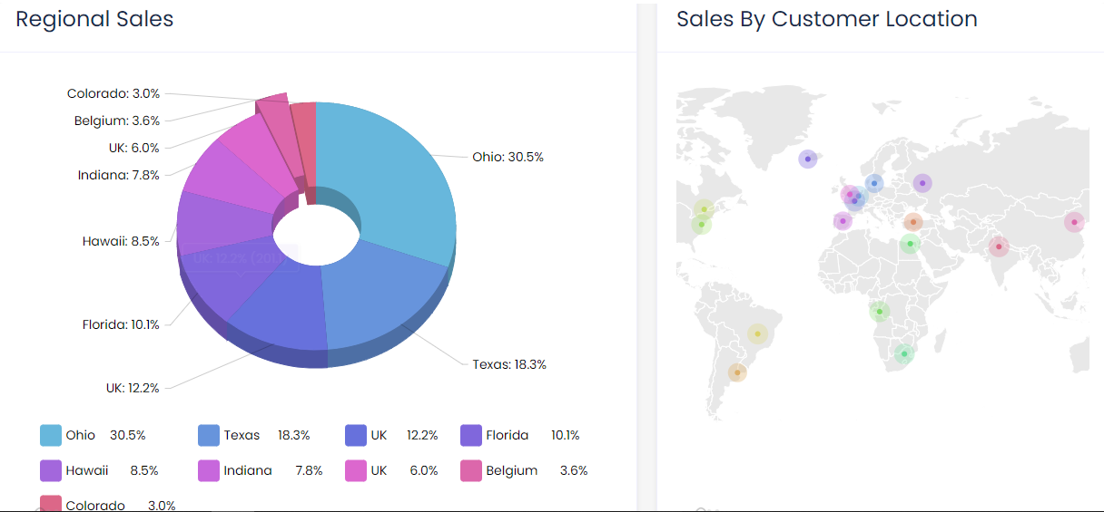

*You need to copy this section as it is from Dashboard.*

1. **Clients**

We want to show 3 boxes here as a “Clients Overview” The design idea you can take from dashboard or anywhere. (i) Total Clients (ii) Active Clients (iii) Inactive Clients

Now let’s discuss about Clients section. We want a preview of Clients section like this (see link below)

<https://crm-admin-dashboard-template.multipurposethemes.com/project_management/vertical/main-mini/projects.html>

(See Attached Screenshot) basically this is a project page, but we want our Client Page look like this.

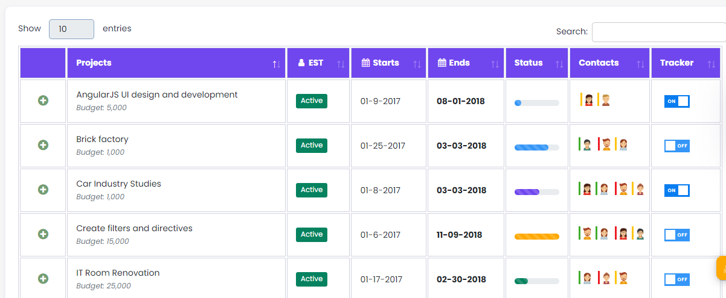

We want some changes in it. Here are those changes.

1. First column will remain as it is with + sign to expand for more information.
2. Second column will be Client Name. We want Client Name first and then Business Name under the client name (same like in the screenshot, Project Name and Budget is under project name).
3. The third column will be the Status of a Client. We will have 2 statuses for clients (Active/Inactive)
4. Our forth column will be State, Country.
5. Fifth column will be the Partner Name (who referred this client to us).
6. Sixth column will be the Date Joined (when he started working with us)

Additionally, we want to have Search Bar in it, and a ***“Add New Client”*** button in it. When someone will click on Add New, the pop up will appear with form to fill out the details of New Client.

Now the question is, what will appear when someone will click on **+** sign. Here is the preview of how it should look like when someone click on **+.**

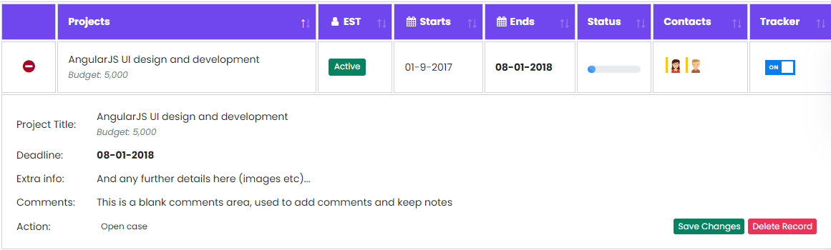

This is how it will appear. We don’t want “Delete Record” button but we need “Save Changes” button. We want to show following information in it. (i) Designation (ii) Phone Number (iii) Business Contact Number (iv) Email Address (v) Business Email Address

Each client will have their own dashboard to access and see project updates. So we also want to show client’s Credentials here. We also want to have “***Edit”*** button there to update the information any time.

1. **Chats**

Now we have Chats tab. See the below screenshot for the better understanding of how we want it to look like.

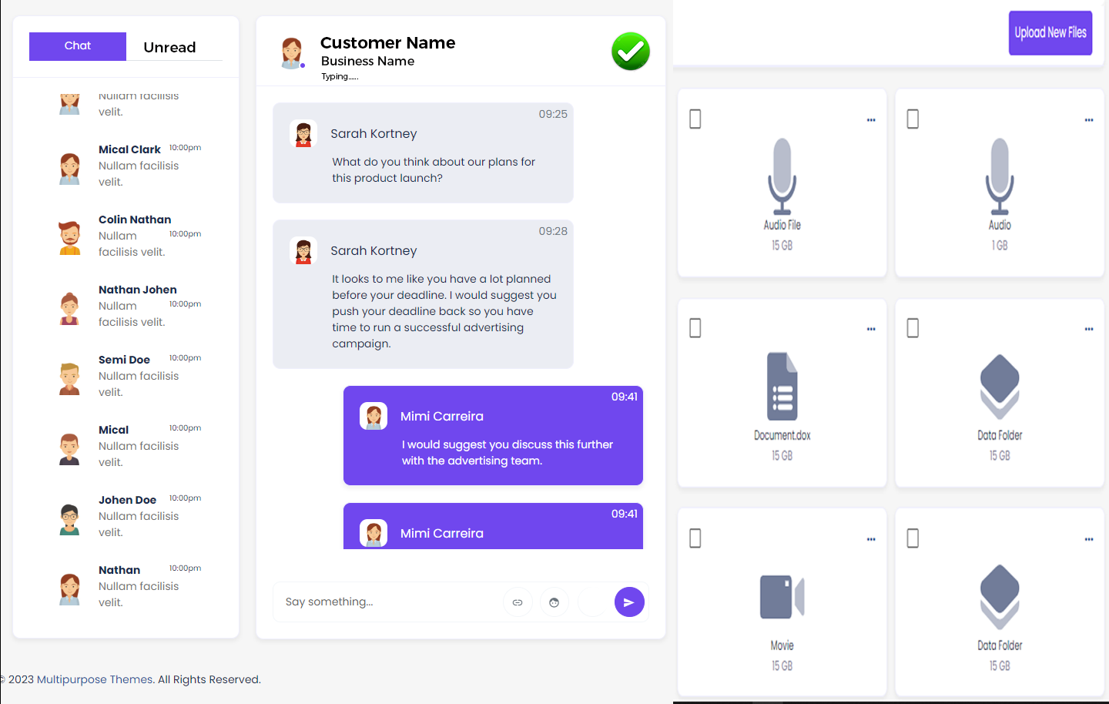

See this screenshot. We want to show chat area Exactly like this. The only difference you need to make is to keep Chat area wider then files area. Only those contacts will be appeared (allowed to chat here) here who are our Clients (in Tab 5). One important point which needs to mention here is that, we need to show Green Check Mark (you can see on top in front of Customer and Business Name). This Green Check Mark will indicate that this client’s billing is cleared/this has no pending payments. And if any client’s payment will be pending or overdue then this Green Check Mark will be converted in to Black White color.

1. **Partners**

Now we have Partners tab. Partners are basically our Sales Team who will bring business to our company. They will work on Commission Basis. See screenshot below (how partners page/area will look like).

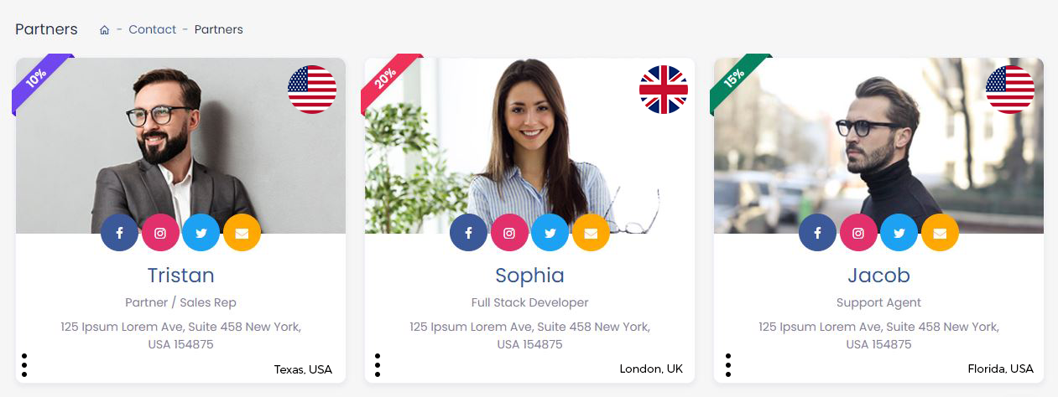

We want to their Profile Picture, Social Media Links, Country Icon (at Top Right Corner), Commission Percentage with Colorful Ribbon (at Top Left corner), Name, Designation, Contact Number, Email, Address also. We also want to show Partner’s State and Country in Bottom Right corner (as you can see screenshot). In bottom left corner, we will use 3 dots to explore more options like edit details, Delete Partner etc. We want to make the image clickable. When we click on image, all of his information must be appeared.

We also want to show ***“Add New”*** button on top right corner to Add New Partners. After clicking on Add New, a popup will appear and we will put all the required information of that Partner. Information include Name, Email, Designation, Phone Number, Address, State, Country, Commission Percentage, and Social Media Links also.

1. **Staff**

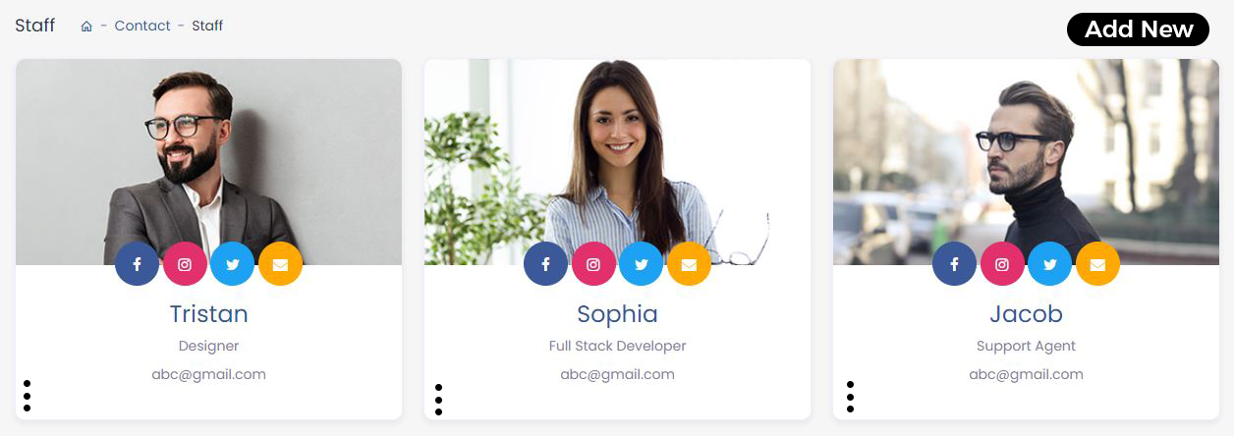

We want to have this look in our staff tab. But we don’t want to show social media links here. We want to show Name, Designation, Email, Phone Number, and Allowed Tabs (will discuss further in detail below). In left bottom corner, as you can see there are 3 dots. These will be for edit or delete purpose. When user click on this Edit and Delete option will be appeared here.

Now let’s discuss, how staff members will work. *(See Attached Screenshot)*

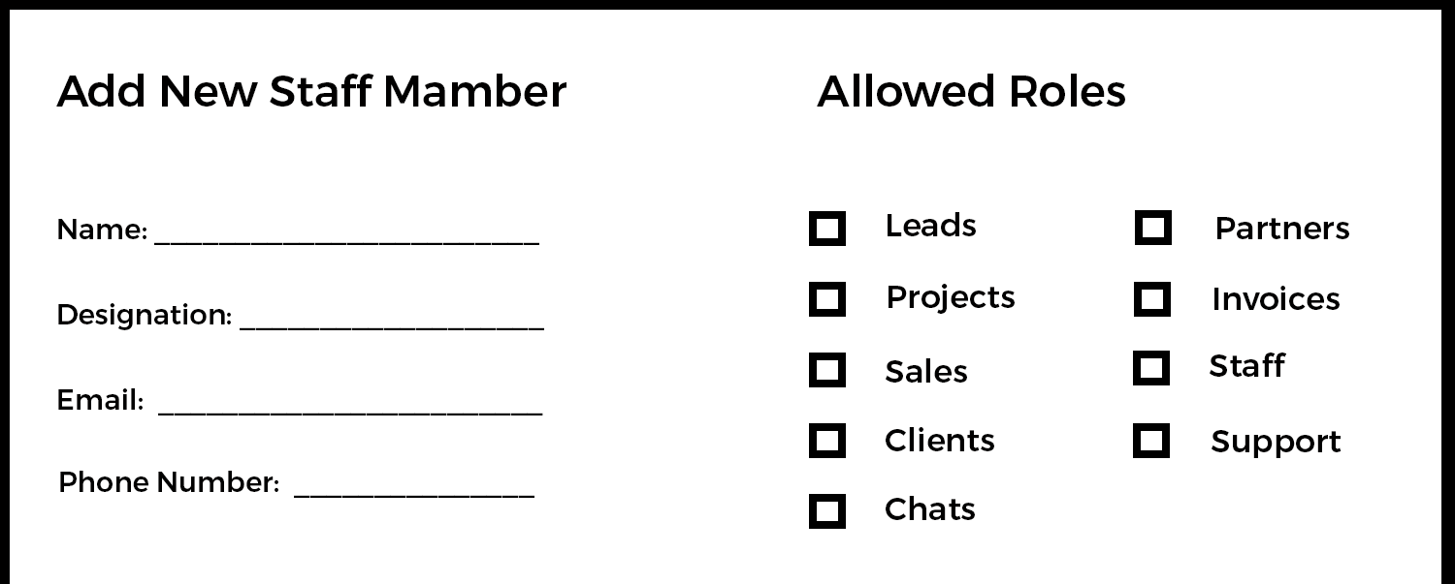

When Admin will click on ***“Add New”*** button (at top right corner) the pop up will appear with this required information. There will be information for staff member like Name, Designation, Email, and Phone Number etc (plus should have an option to upload an image as well). Next you can see ***“Allowed Roles”*** under this area there will be checkboxes to allow a staff to an access to specific part (Add a Save button (sorry, forgot to add in a picture).). For example, we have hired a Customer Support Expert and we want to allow him an access of Support and Chat Tabs only. So we will allow him access of only 2 tabs from here. Rest of them will not be visible to him. Another example is, we need a project manager and we will show him tabs of Projects, Clients, and Leads only. Rest of the tabs will not be visible to him. This is how it will work.

*(Need to integrate Automatic Email System also, when we add a Staff Member, an email with dashboard logins must be sent to his email address which is provided in mail field).*

1. **Support Ticketing System**

Lastly, we will have Support Ticketing System in our CRM where Client will open a ticket when He / She will face any issue. You can search on google and see how does it work. It’s been really common now a days. But we will share screenshots with complete description to explain you further.

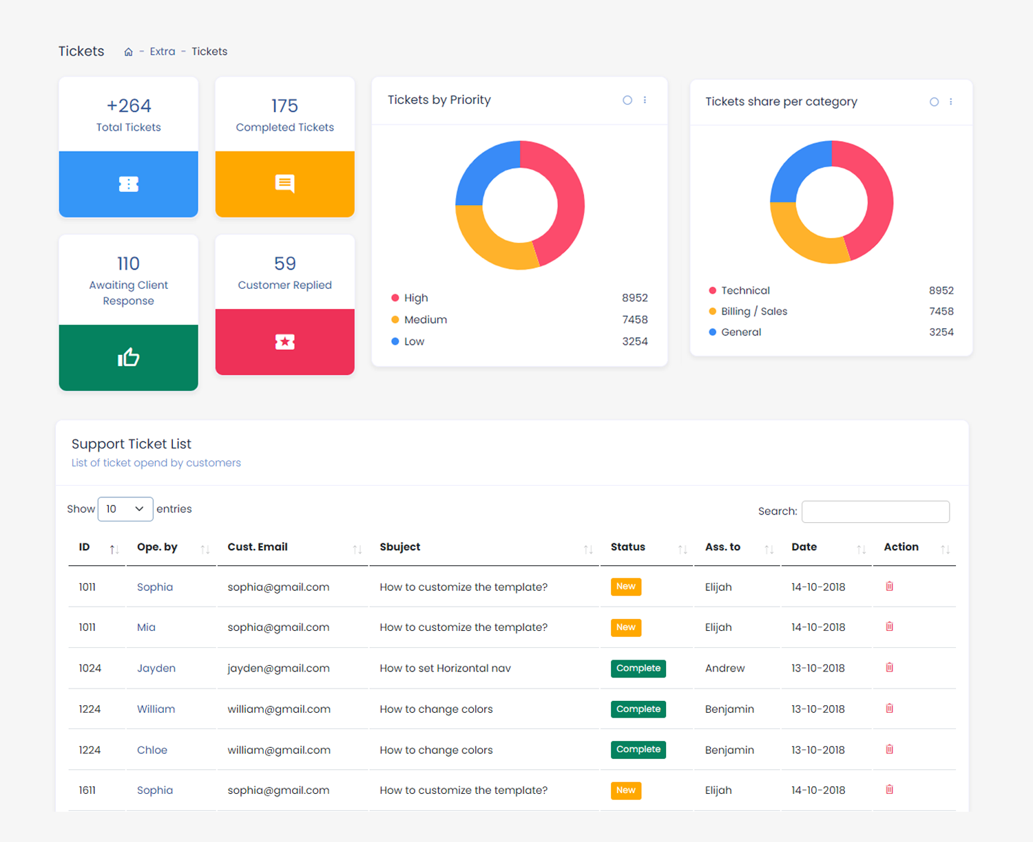

This is how the layout and design will be. This template is in the links we have shared with you. There will be 4 possible status of tickets. When a client faces any issue, he will open a ticket to resolve the issue. The statuses will be

1. **Completed:** The Status of ticket will be marked as completed when issue will be resolved.
2. **Awaiting Client Response:** This status will appear when Company/Support team has replied to the issue and they are waiting for more information from client. (Ticket will remain open)
3. **Customer Replied:** This status of ticket will appear when Customer has replied to our answer and we/company needs to answer them.
4. **Open:** When first time client will open a ticket, the status of ticket will be shown as Opened. This will be visible for first time only. Because when company customer support will reply the status will be turned to “Awaiting Client Response” and when customer will reply the status will be turned to “Customer Replied” and this will go that way, until the issue been resolved. Once the issue has been resolved, Company will have an option to close the ticket. Then, the Status will be marked as “Completed”.

In the above screenshot you can see 4 boxes, we need same like that. All 4 boxes options will remain same. Next we have “Tickets by Priority” option. We also need this option there as well. When client will open a ticket he will have a an option to set a priority of his issue, he must be able to choose the priority (Low, Medium, High) and all those will be recorded on this box also. Next we will have 3 kinds of ticket. It depends on what kind of issue he is facing. There will be 3 options (i) General (ii) Technical (iii) Sales/Billing

Below in ***“Support Ticket List”*** we need to have following rows to show information.

The Rows will be (i) ID (Automatically Generated Ticket ID) (ii) Customer Email (iii) Subject (iv) Status

(v) Priority (vi) Last Update Date (vii) Opened Date

*(We don’t want to have any horizontal bar in it. Plus, we* ***do want to add Search bar on top*** *of Ticket list, as you can see in the above screenshot).*

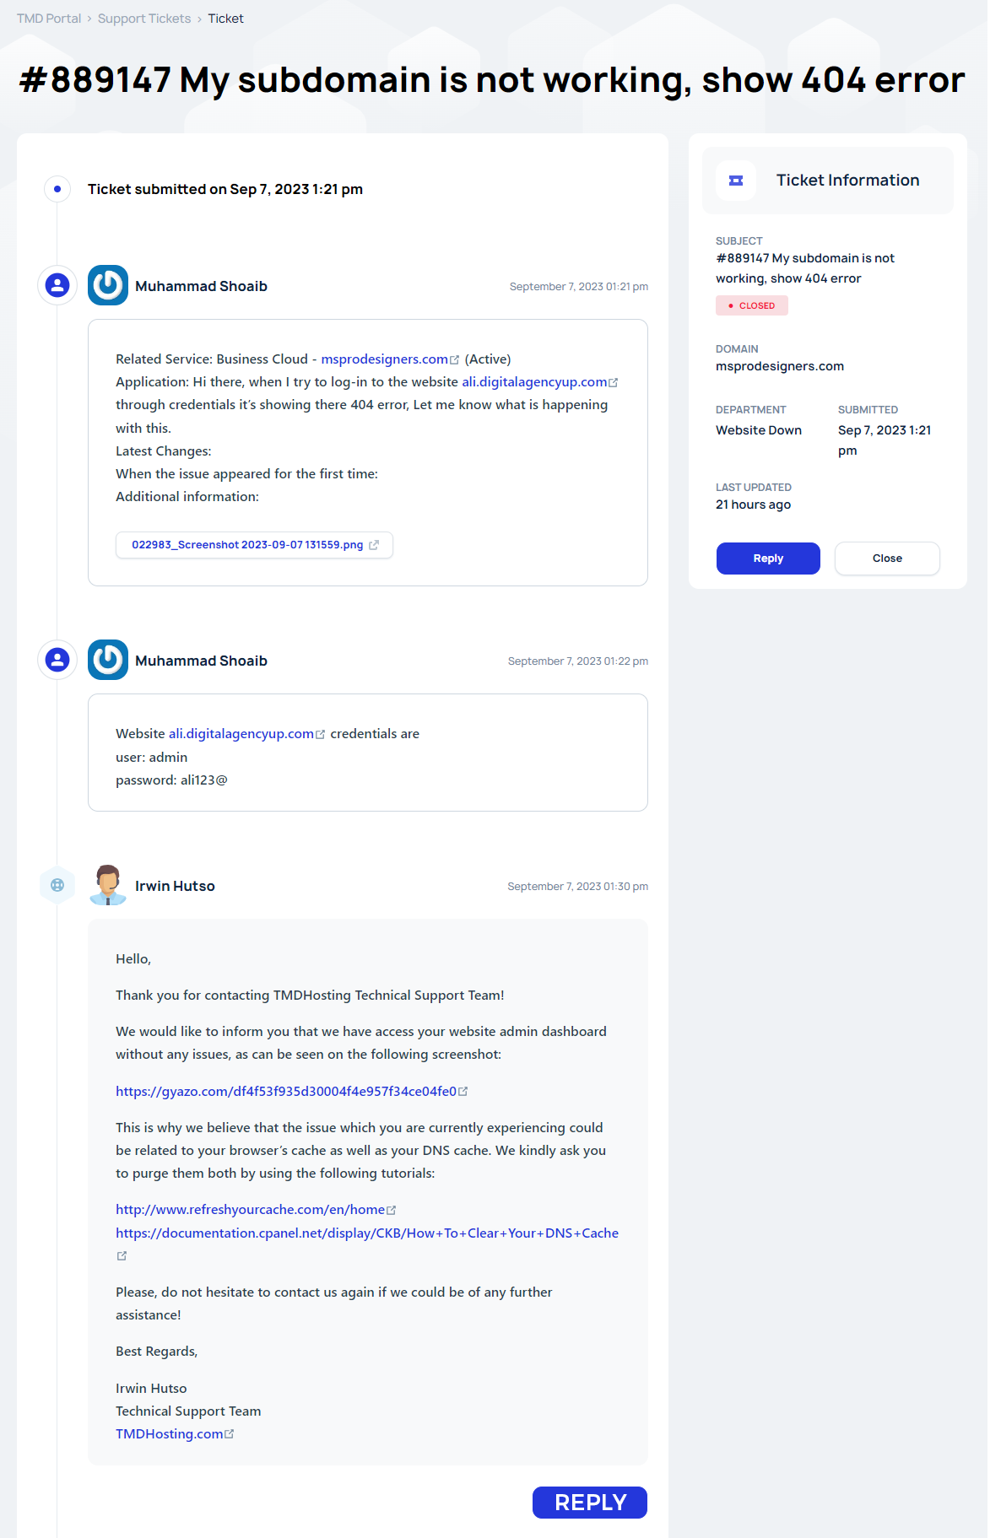

This is how the Ticket Page will look like. Over here, we will be replying to the issue of client. In this screenshot you can see customer and company message layout, reply button, close button, ticket and other information too. This is the perfect example of how page looks like. This is just an idea. You need to merge this to the main design of our CRM. The sample design links have been shared already.

*(Need to integrate Automatic Email System for client, when he opens a ticket, when we reply to his ticket, and when ticket mark as completed, all these updates about ticket must be emailed to the client to keep him updated).*